**Working with Out bound email, DSS( Dynamic System Settings), Correspondence & Correspondence Fragments, Passing Parameters in Activity:**

**Sending Email Notification: ( Activity)**

**Purpose is to Add From Email Address**

**In order to send email notifications PRPC Provided an built in Activity : sendemailnotification**

**From Email Parties:**

* **Send email Notifications**

**Predefined Activity: SendEmailNotification**

**To Email:**

**From Email:**

**Subject:**

**Message:**

**HostName: ( To Email)**

* **Integration -> Email-> Email Accounts ( Out Bound Email )**
* **Integration Resources -> Email Account**

**Dynamic System Settings(DSS):**

**Purpose: To add Global constant values we can use DSS**

**DSS is a Sysadmin Rule**

**DSS Parameters: DSS Name, Owing Ruleset, Setting Purpose**

**After Defining DSS, to access the DSS rule we have to use a function:**

**Function Name: getDataSystemsetting( Ruleset, DSSName)**

**Correspondence:**

**While sending notifications correspondence is used to define the message body.**

**Correspondence Types:**

**Fax**

**Email**

**Mail**

**SMS**

**- To use Correspondence in Activity we use a Method: Property-set-Corr**

**Correspondence Fragment:**

**Fragment is small portion of message which can reused in Correspondence rule**

**Ex: Greetings & Signature in message body**

**- Fragment we have call in Correspondence**

**- Fragments are reusable portions in Correspondence**

**=======**

**Req:  Implement DSS & Correspondence to send email notification using Activity.**

**- Send email Notification with shipping address details in the email body**

**- Subject must be : Review Shipping Address Details & Include Work Object ID in Subject**

**- Address/Greet the Customer with FirstName. First Name should be taken from Customer form**

**- The Greetings & Signature should be reusable for other correspondences**

**- From Email, Password, Host Name must be defined globally ( Using DSS)**

**- To Email Address must be taken from customer form**

**Add DSS( Dynamic System Setting) Rule:**

**FromEmail**

**Password**

**HostName**

**First Check Email ID Property is there in Customer form or not.**

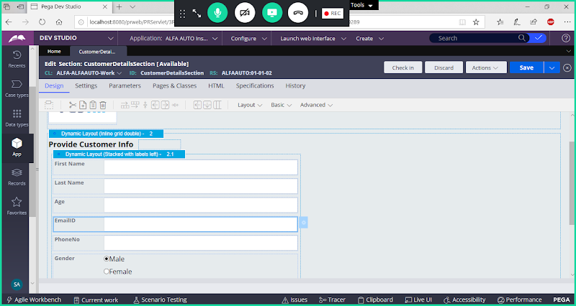

**Create DSS for FromEmail:**

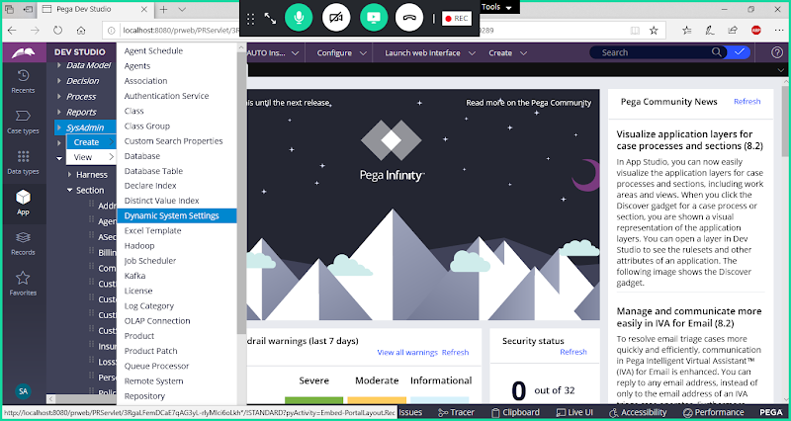

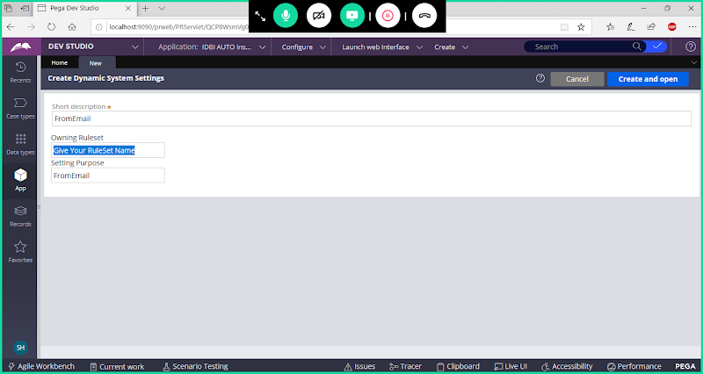

**Ruleset Name = DivisionName**

**ALFAAUTO = ALFAAUTO**

**Ex: ALFAAUTO**

**open**

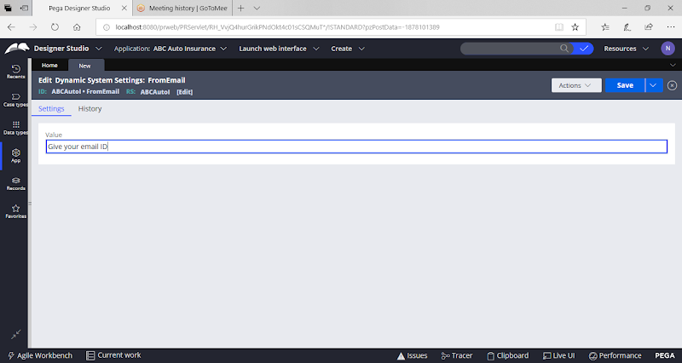

**Save**

**Create DSS for Password:**

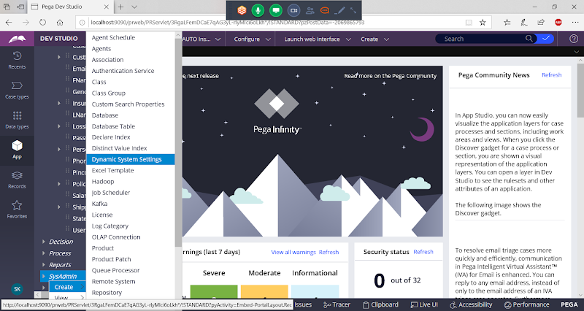

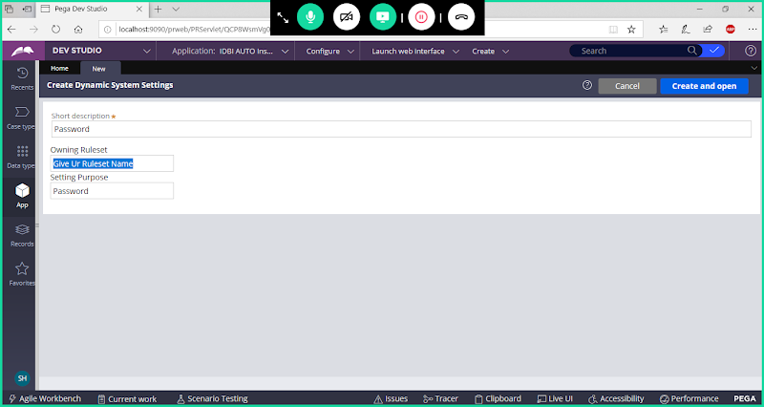

**Open**

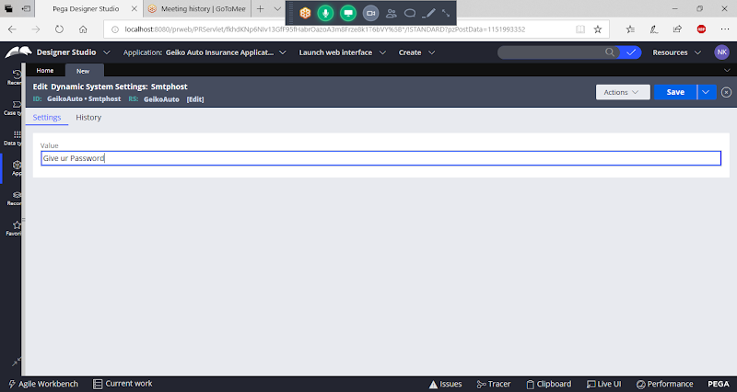

**Save Dss**

**Create DSS for smtp host name:**



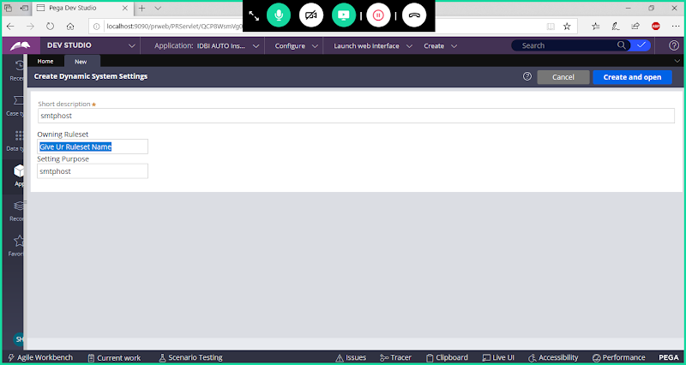

**open**

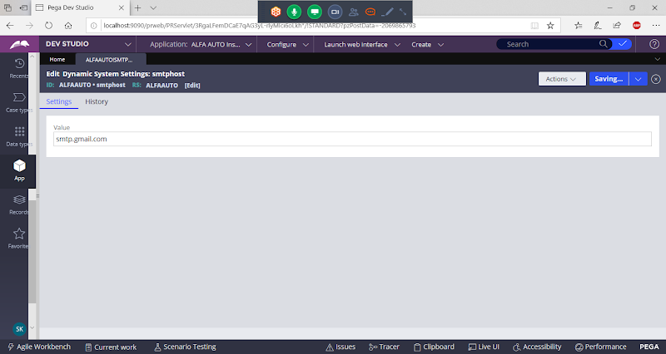

**Save dss**

**Create Correspondence Fragment Rules:**

**Create Correspondence Fragment for Address/Greetings:**

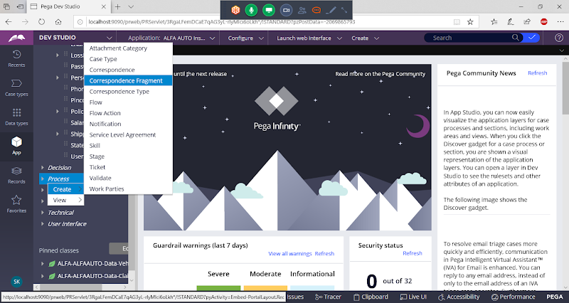

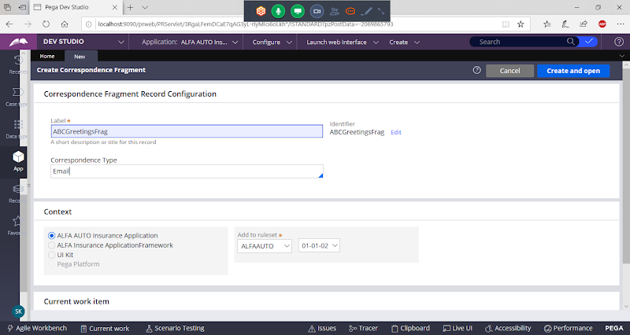

**Open & Go  to Pages & Classes**

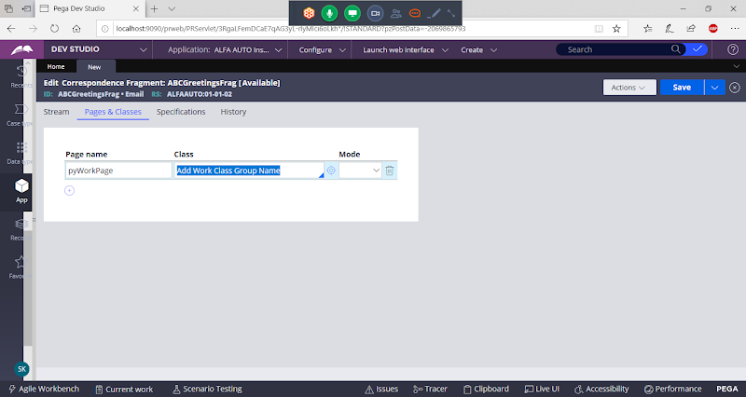

**Go to Stream tab:**

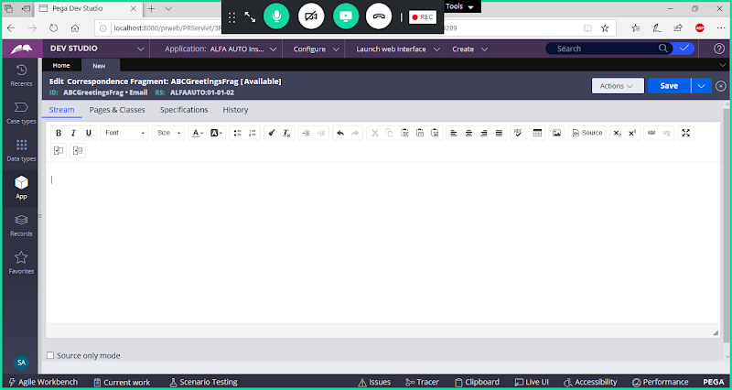

**After Dear give space & click on Insert Property control**

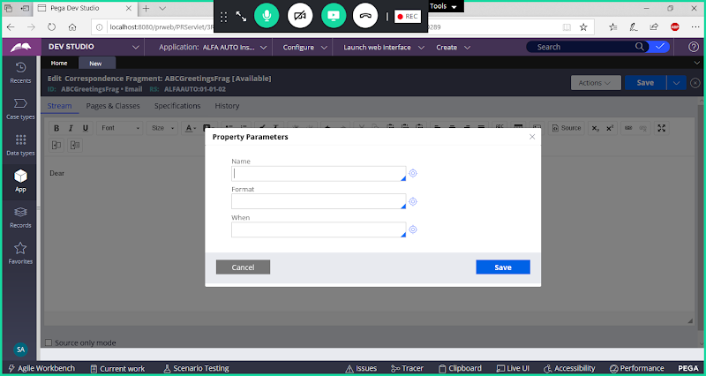

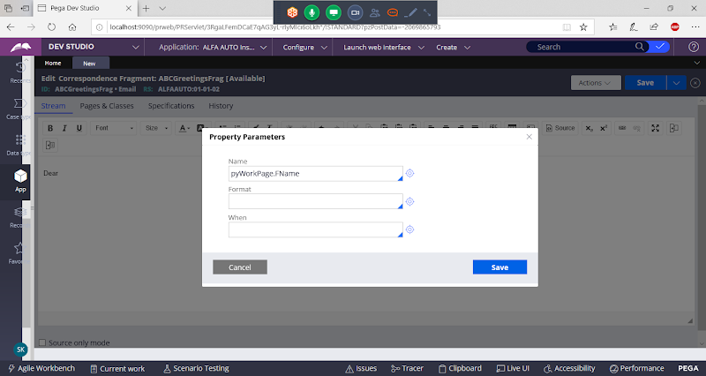

**Save**

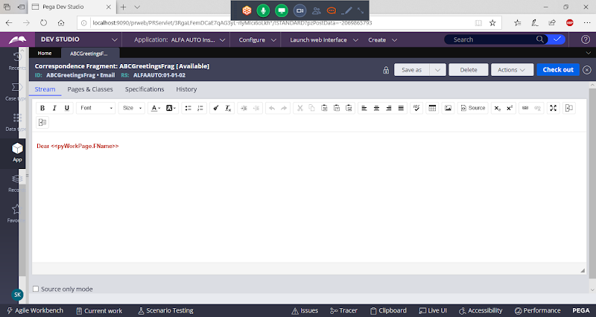

**Save**

**Add Signature Fragment:**

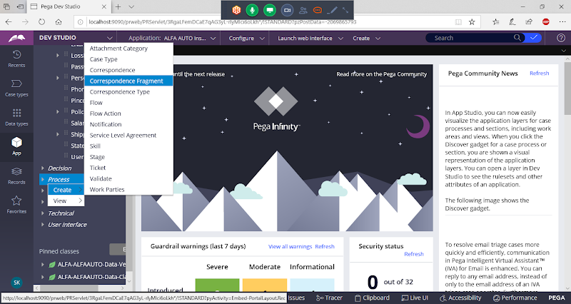

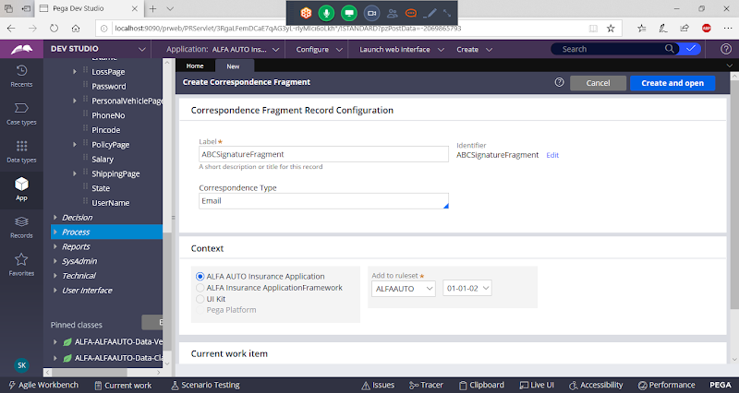

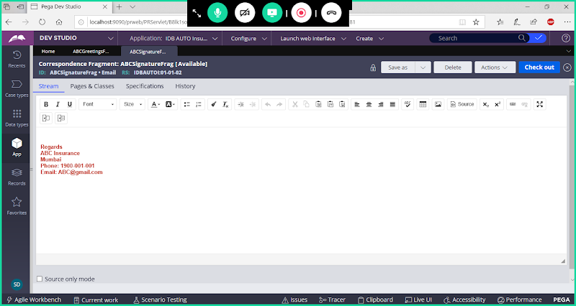

**Save**

**So, Correspondence Fragments we have to map in Correspondence Rule.**

**Open Shipping Address section & Set Fields as Read Only.**

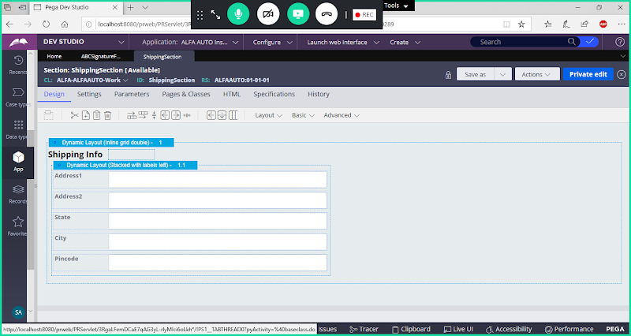

**Create Correspondence Rule:**

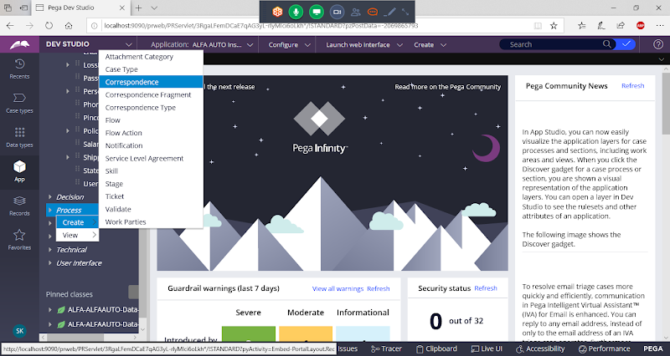

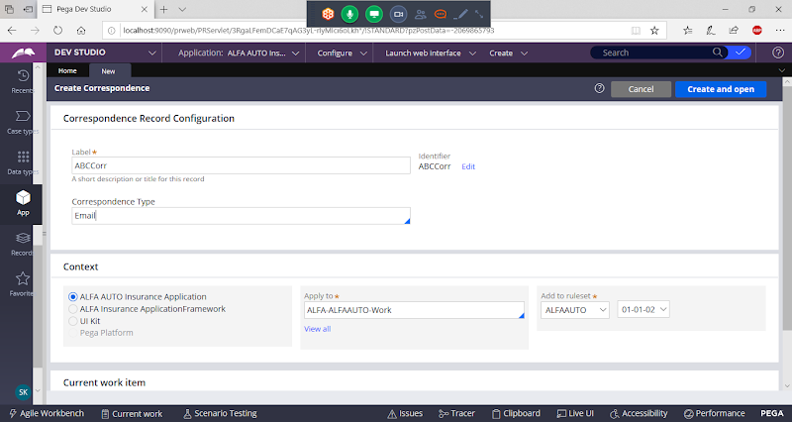

**Open**

**Go to Pages & Classes**

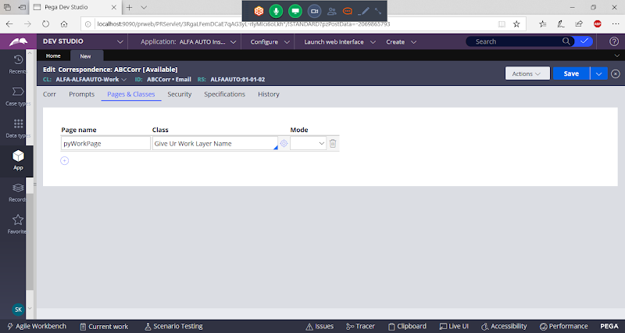

**Go to Corr Tab:**

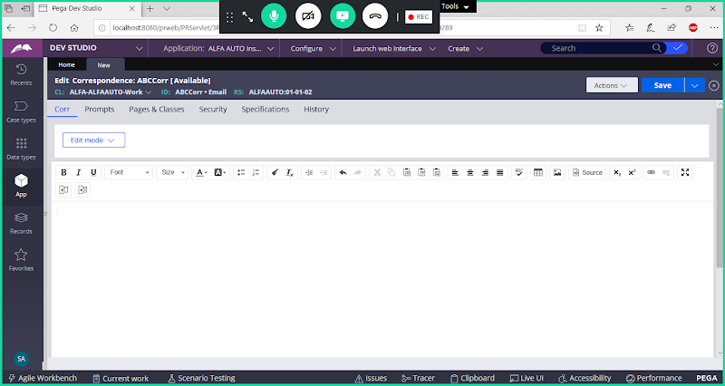

**1- Call Fragment Rule to add Greetings ( Click on Insert Rule)**

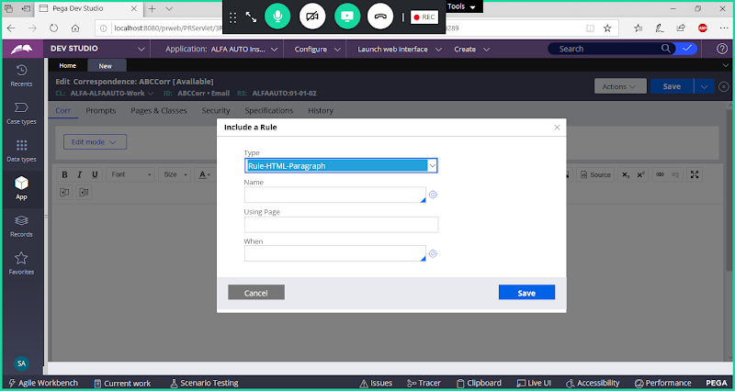

**Select Rule-Corr-Fragment**

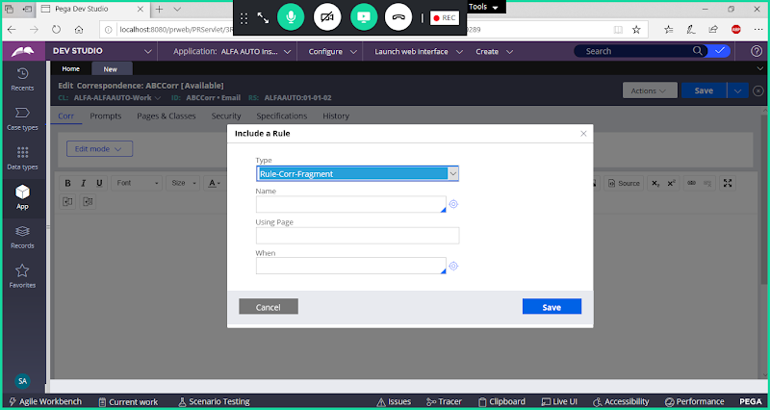

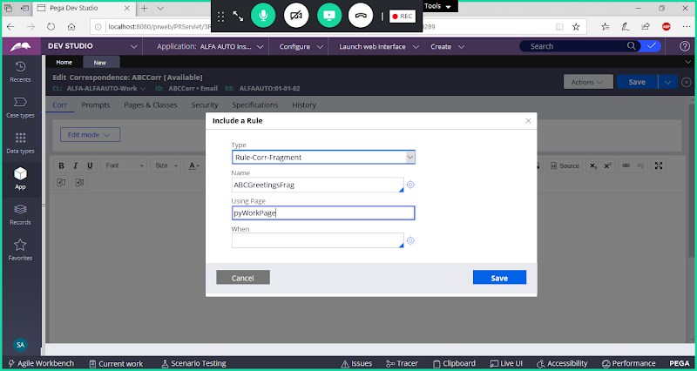

**Save**

**2- Add Message**

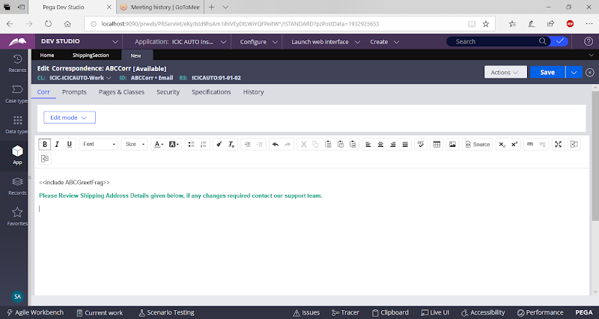

**3- Add Shipping address section**

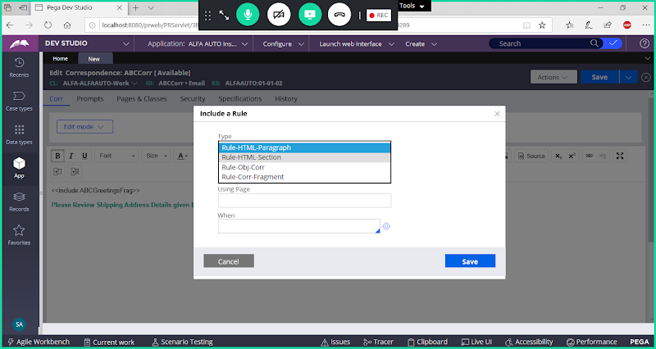

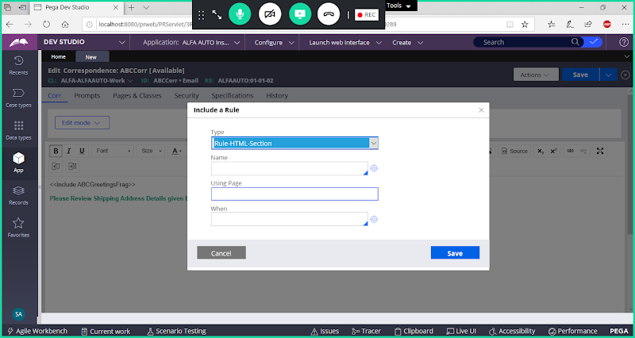

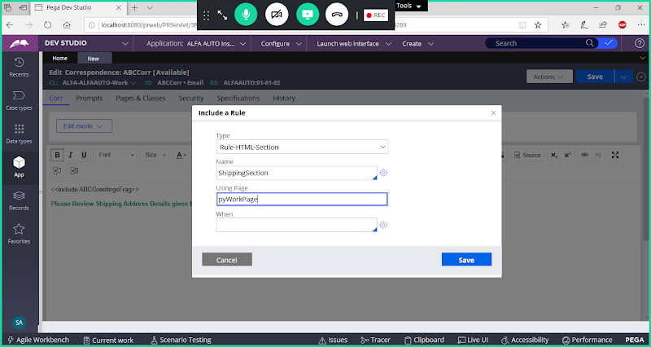

**Save**

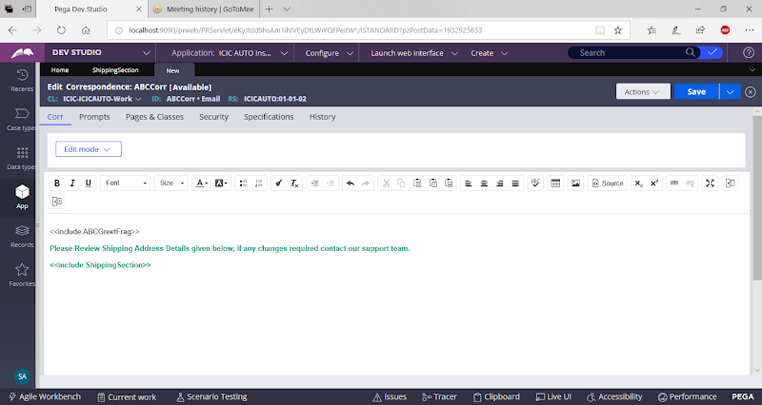

**4- Add Signature Fragment**

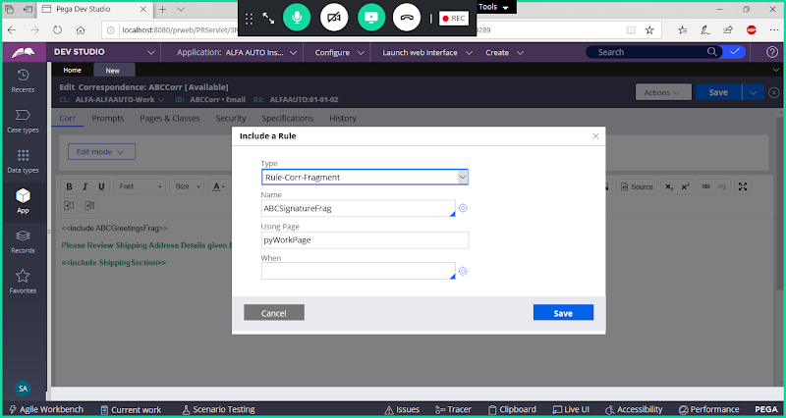

**Save**

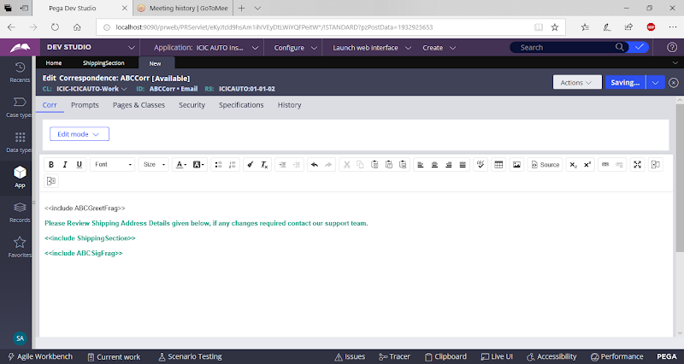

**Save Correspondence**

**Create Activity  Rule:**

**Open Existing Activity : Send Email Notification**

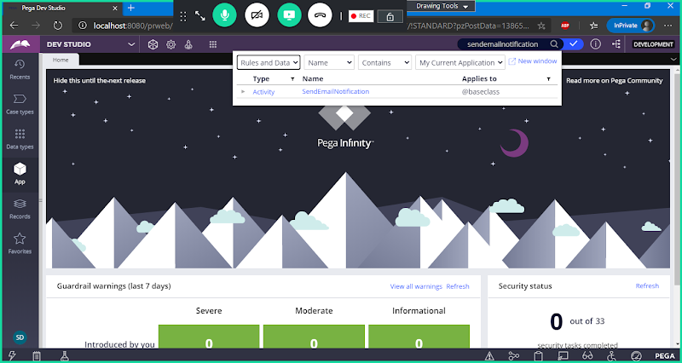

**Open Activity**

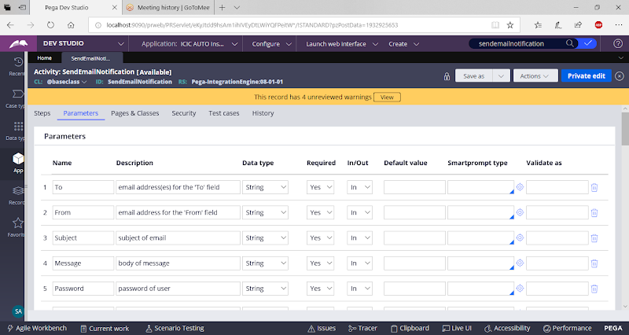

**Use Saveas Option**

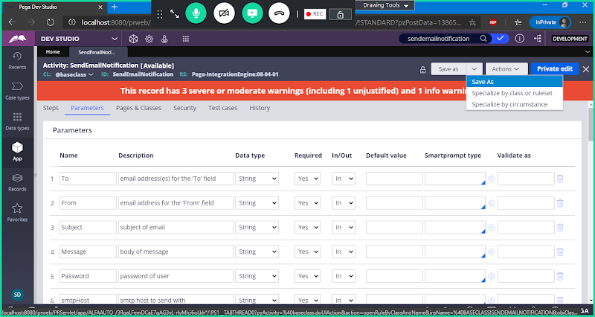

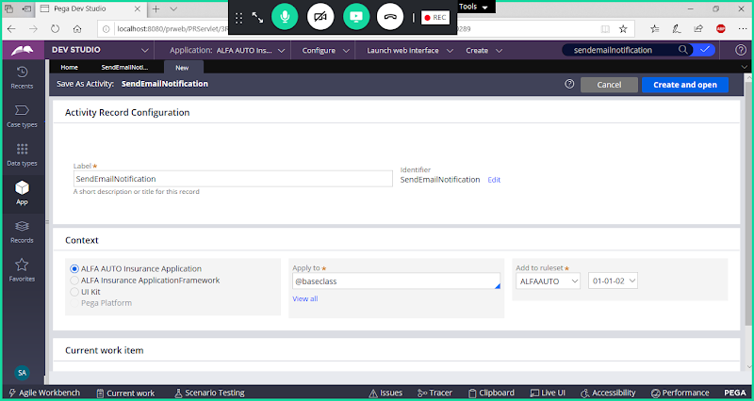

**Change Rule Name & Class Name**

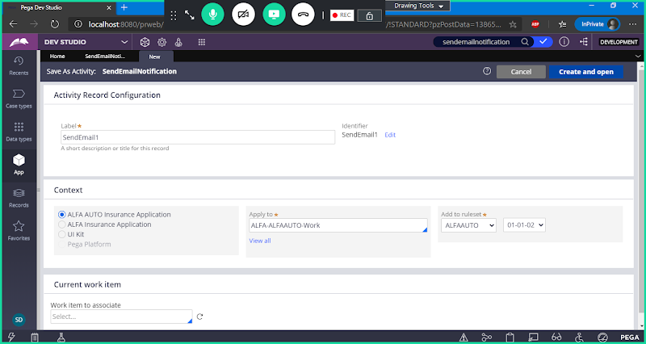

**Open**

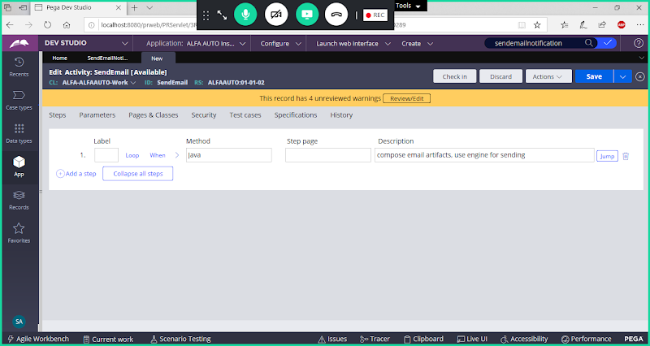

**Delete Step in Activity**

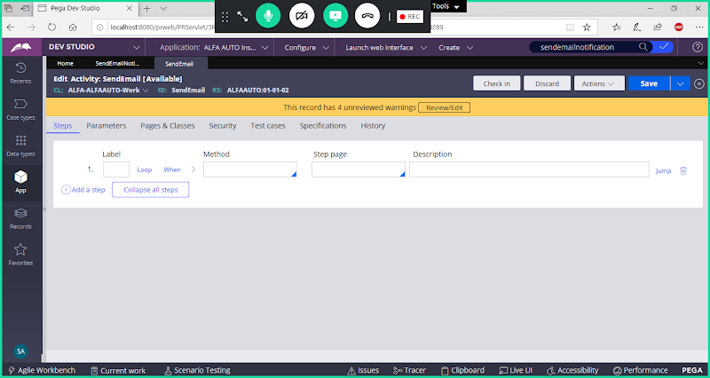

**This Activity contains Default Parameters, we can use them for our requirement**

**Go to Steps Tab & Add Methods:**

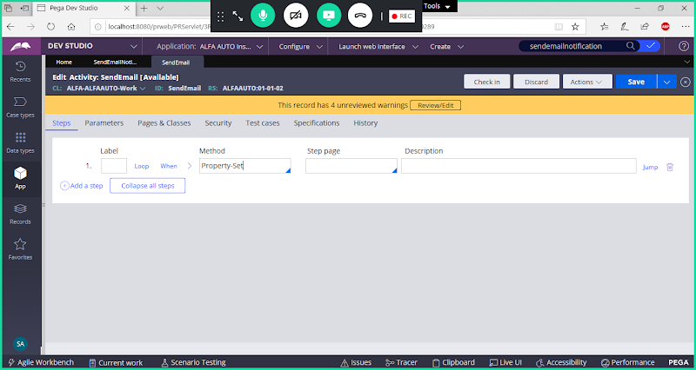

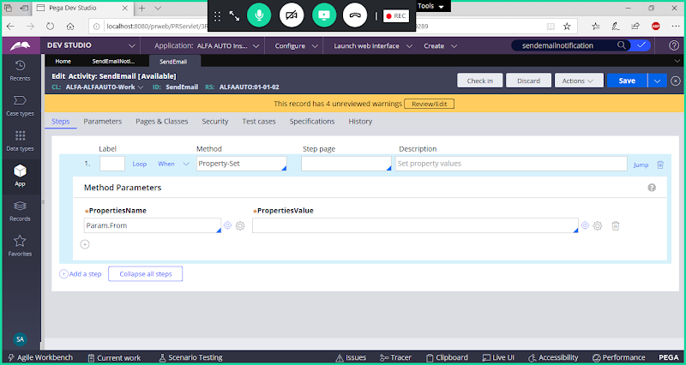

**Open Expression Builder & Add Function: getDataSystemSetting**

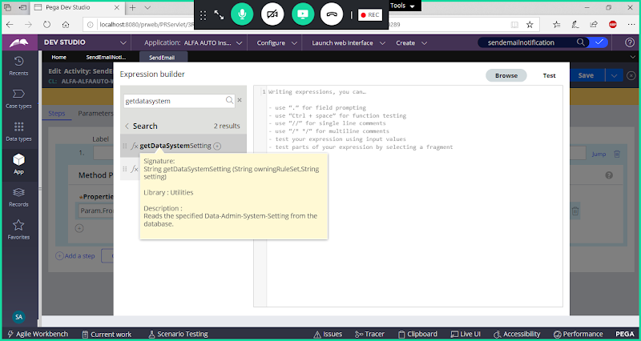

**Select Function with 2 Parameters**

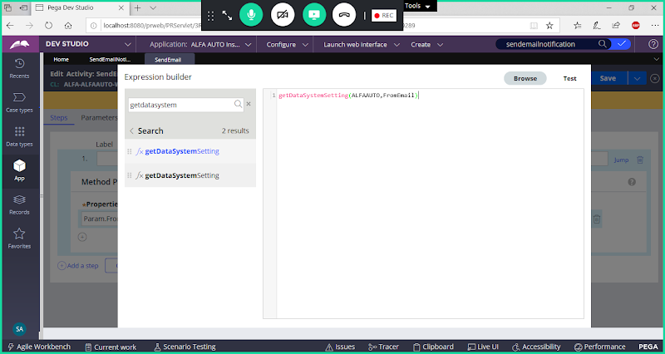

**Click on Test**

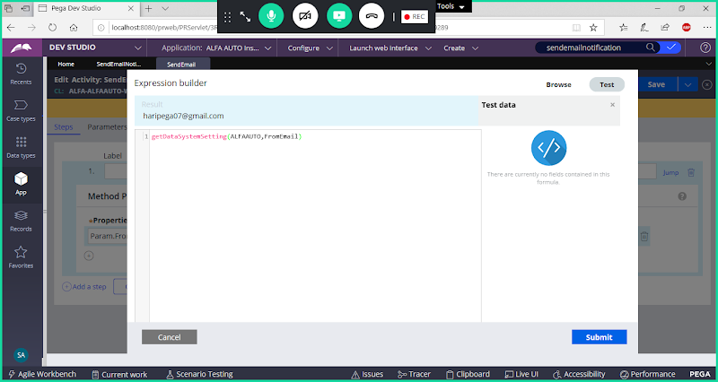

**Submit**

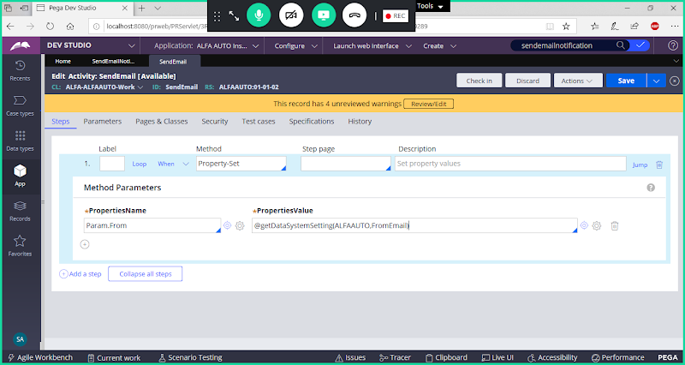

**Now Add Password & SMTPHost Name**

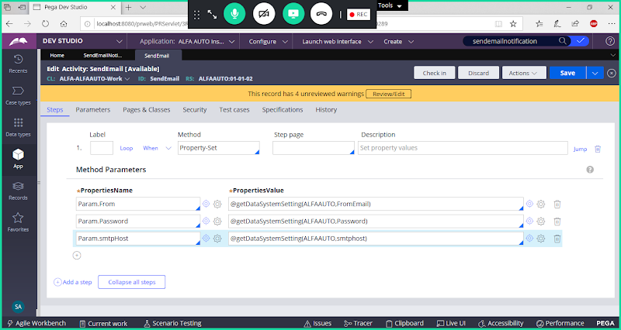

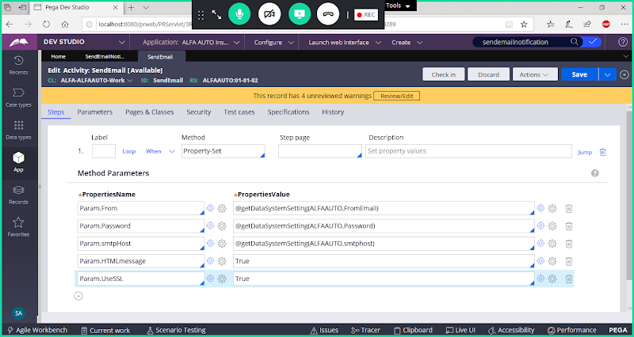

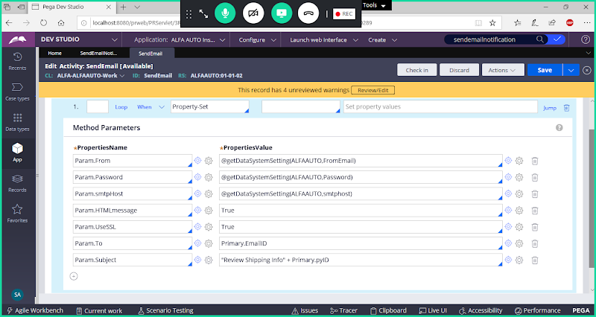

**To Call Correspondence Messages in Activity we can use Property Set Corr Method**

**Add New Step**

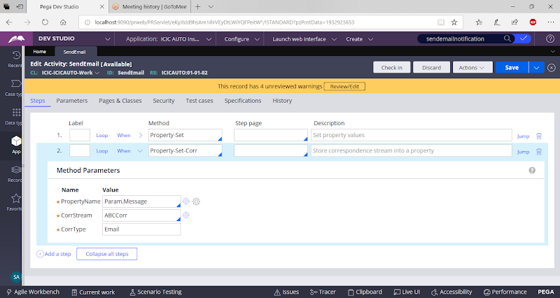

**Add New Step to pass parameters from One Activity to Another Activity**

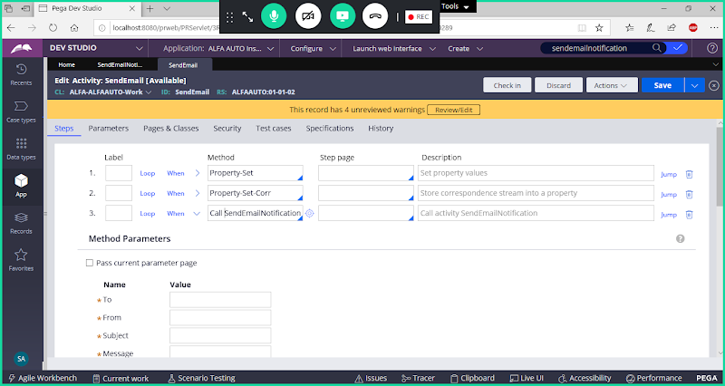

**Enable Check Box : Pass Current Parameter page**

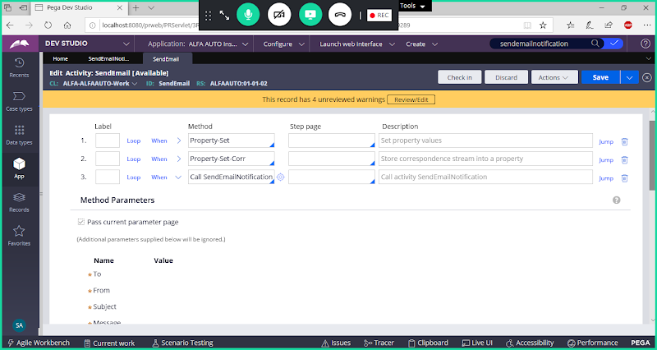

**Save Activity & Call This Activity Address Flow action -> From Action tab-> From Post Processing Call this Activity**

**Open Address Flowaction:**

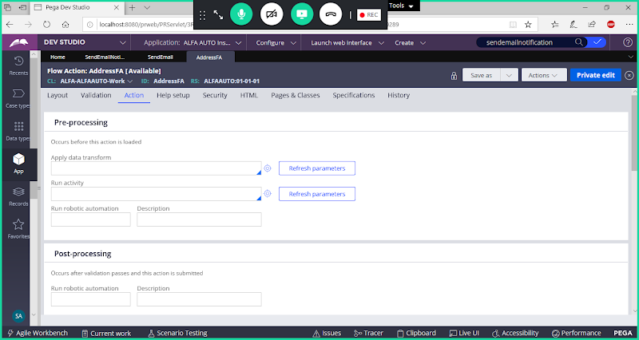

**Call activity under Post Processing Activity:**

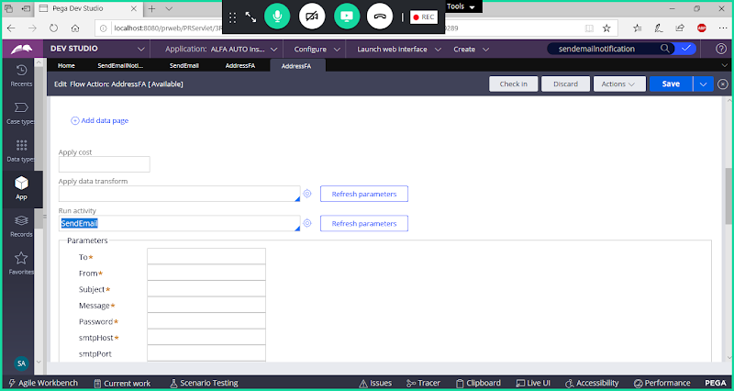

**Save & Check in**

**Run Insurance Flow**

**Provide : First Name  & Email ID in Customer Form & Provide Address Details in Address Form**

**First Run the Screen Flow**

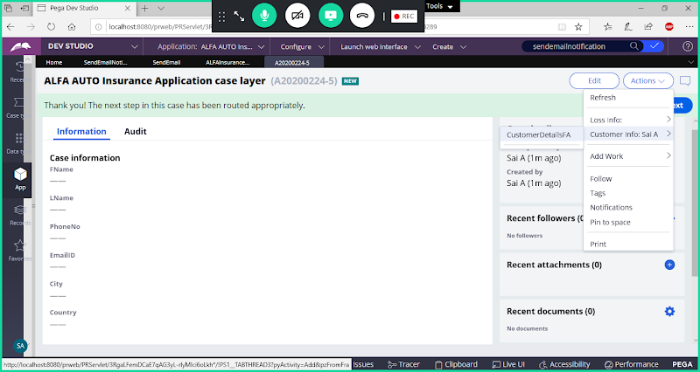

**Add First Name & EmailID**

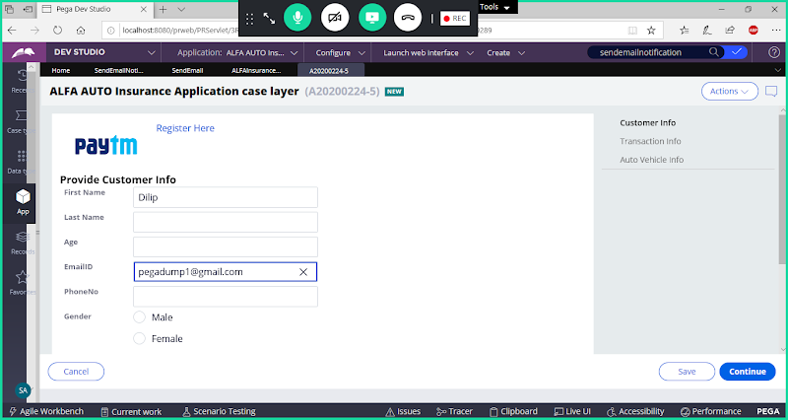

**Continue & Finish Screen flow steps**

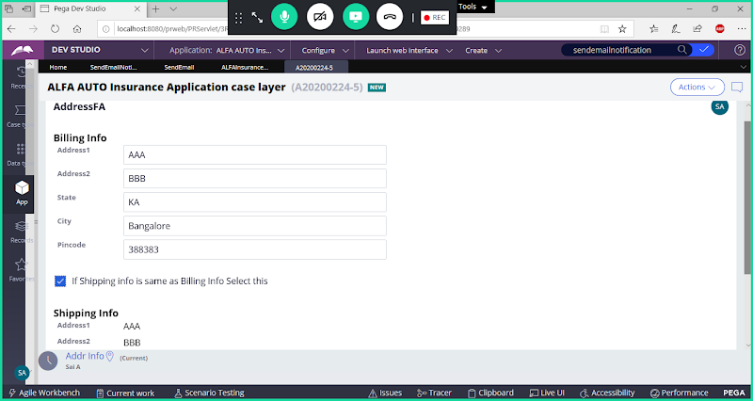

**Enter Records in Billing Page & Select Check box**

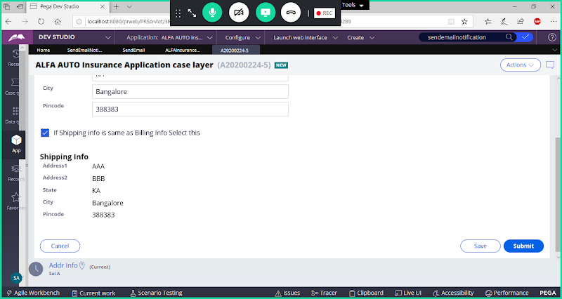

**Submit**

**Now Check under To Email ID:**

